OLYMPIC NATIONAL PARK,USA

“Understanding the impact of conservation efforts in the Olympic National Park,USA from the viewpoint of ecologocial,soil resources and the complex ecosystem.”

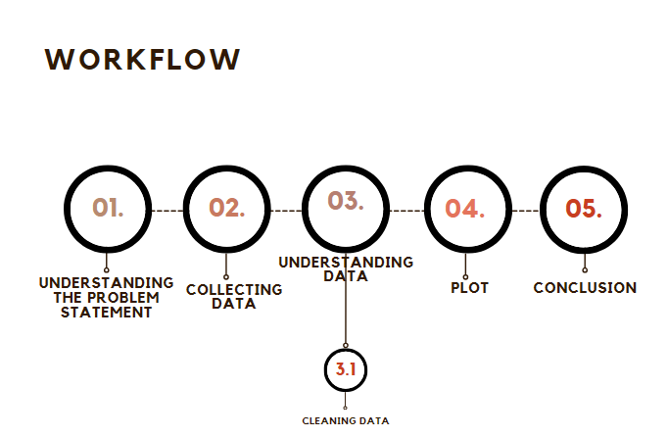

LOCATED-WASHINGTON,USA

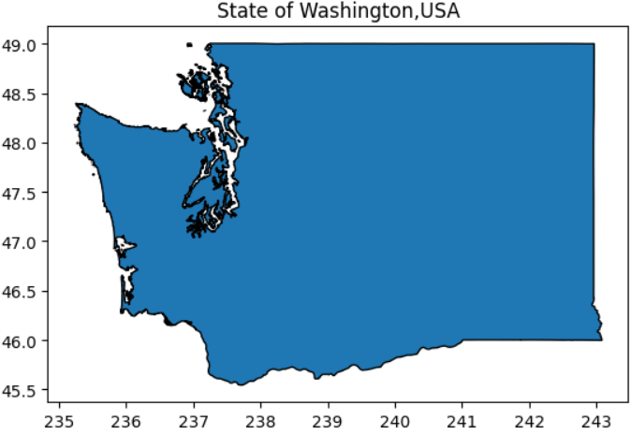

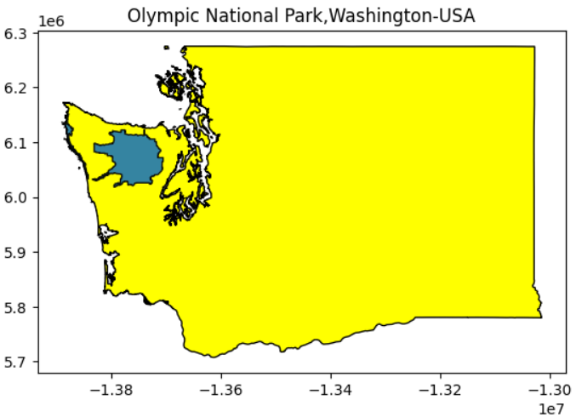

The Olympic National Park boasts rich and varied ecosystem. Ranging from coastline to temperate mountain system and glaciers.

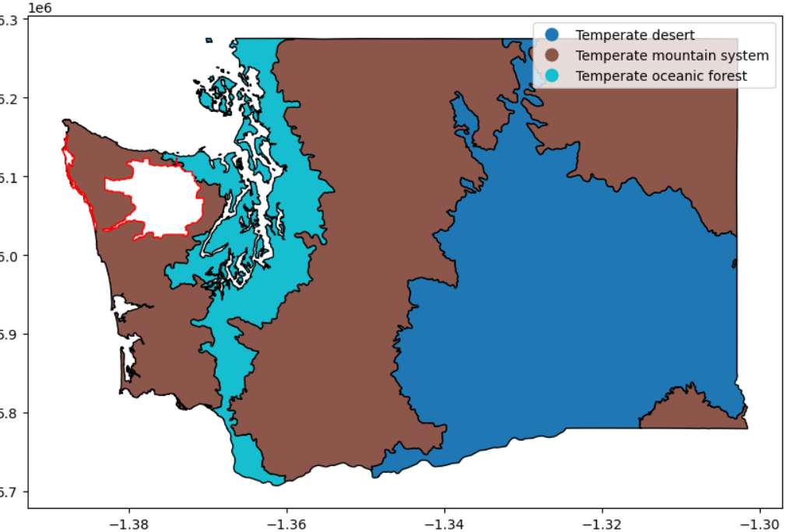

The soli resources are equally important in this regard.

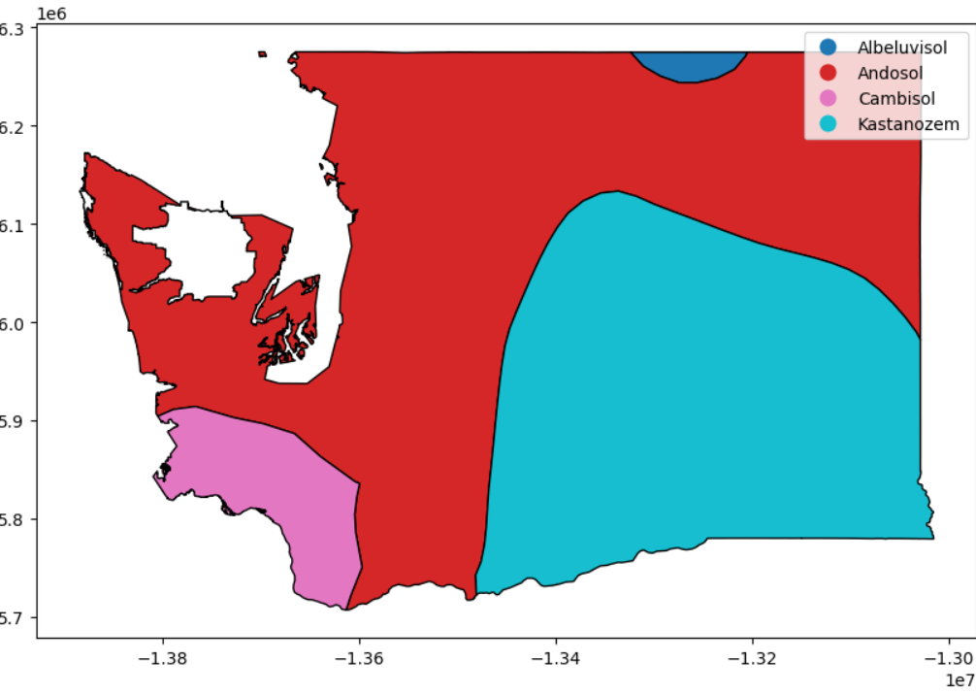

The white region here depicts the Olympic National Park. According to the data on “World Soil Resources” the region is classified as Andosol.

Andosol is described as “unique soils found in volcanic areas, formed from volcanic tephra (such as ash, tuff, and pumice).” The soil supports productive forests. Therefore, it is important that is region is conserved to promote forest cover.

The forest cover of USA can be visualised graphically:

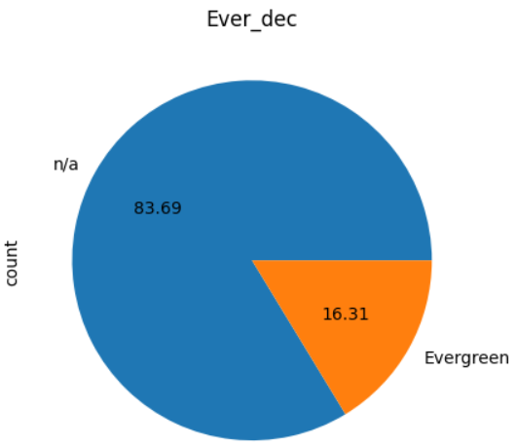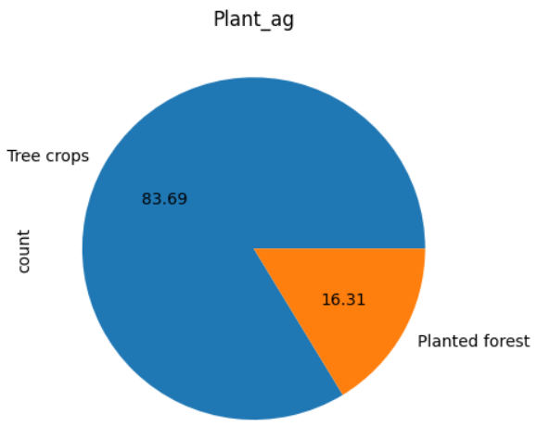

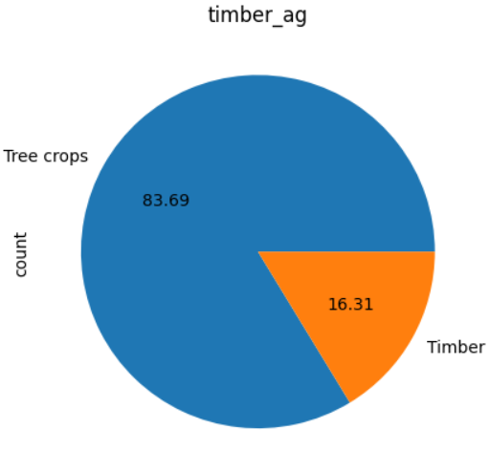

We now visualize the forest cover in and around Olympic National Park,

Washington, USA

1. We can see the region in and around the Olympic national park has “*Pseudotsuga menziesii*” and “*Punica granatum*”.

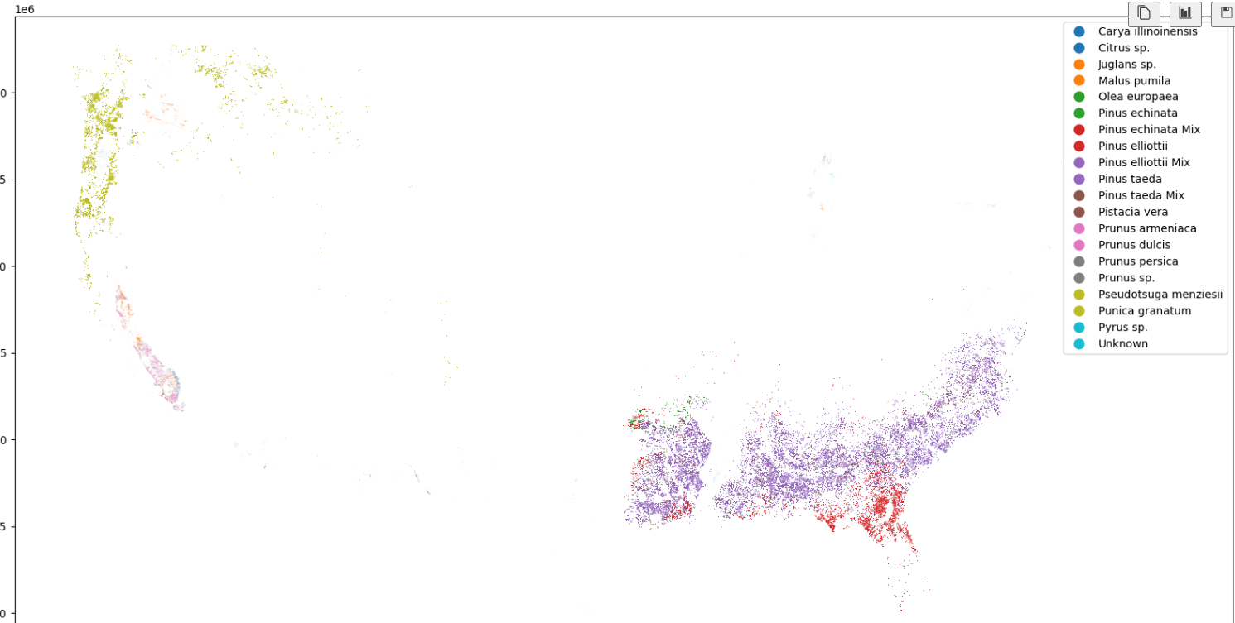

1. The coastal region of the Olympic National Park is predominantly Planted Forest but we also a few data points for Tree Crops along the costal line are also seen.

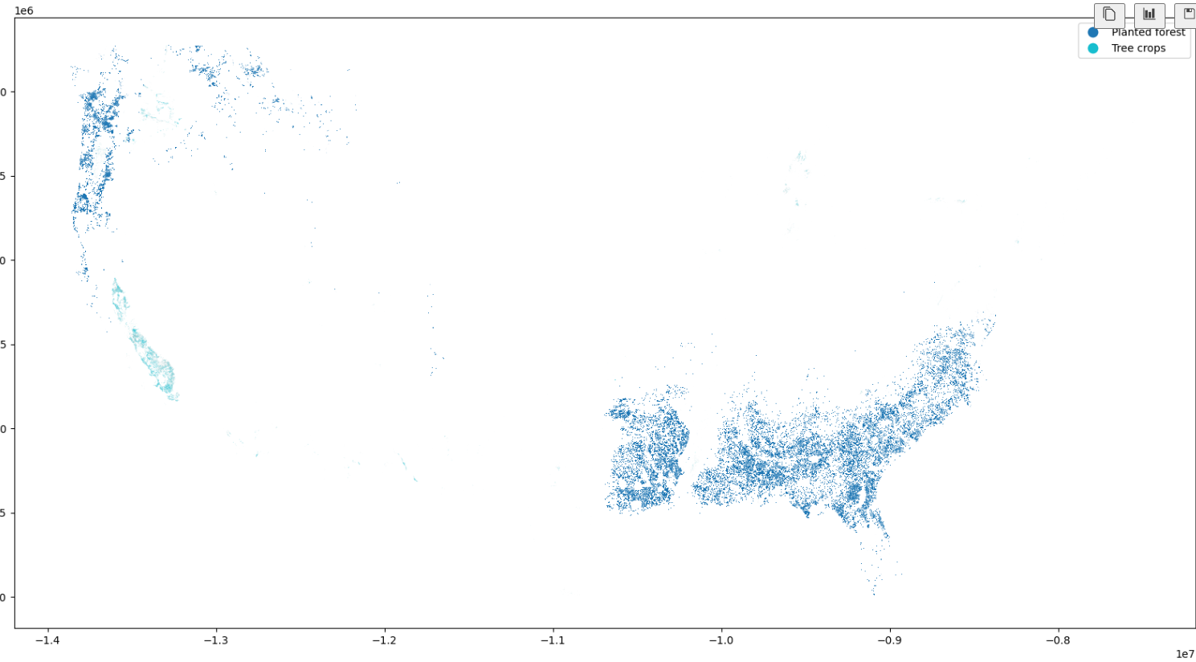

3.Evergreen forest dominate the region but a significant amount of plants away from the coast are unknown which raises concerns.

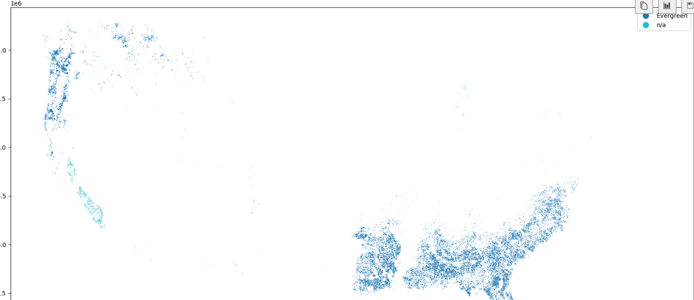

1. The plantation is majorly Timber such forests are biodiversity hotspots, hosting a wide range of species.

